MA 322 (2021) Scientific Computing Lab Lab 07

**Name:** Udandarao Sai Sandeep

**Roll Number:** 180123063

**Dept.:** Mathematics and Computing

**Q1:**

Using the Runge-Kutta method of order 4, the number of units of KOH that will be formed after 0.2 seconds has been determined.

# Units of KOH after 0.2s is:  53731.39630040521

**Q2:**

Using the Runge-Kutta method of order 2 and Modified Euler Method, the approximations to the IVP was calculated for different values of h.

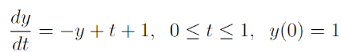

|  |  |  |  |
| --- | --- | --- | --- |
| h | x | 2nd order Range-Kutta | Modified Euler Method |
| 0.1 | 0.1 | 1.005 | 1.005 |
| 0.1 | 0.2 | 1.0190249999999998 | 1.0190249999999998 |
| 0.1 | 0.3 | 1.0412176249999998 | 1.0412176249999998 |
| 0.1 | 0.4 | 1.070801950625 | 1.070801950625 |
| 0.1 | 0.5 | 1.107075765315625 | 1.107075765315625 |
| 0.1 | 0.6 | 1.1494035676106404 | 1.1494035676106404 |
| 0.1 | 0.7 | 1.1972102286876296 | 1.1972102286876296 |
| 0.1 | 0.8 | 1.2499752569623048 | 1.2499752569623048 |
| 0.1 | 0.9 | 1.3072276075508857 | 1.3072276075508857 |
| 0.1 | 1 | 1.3685409848335515 | 1.3685409848335515 |
| 0.2 | 0.2 | 1.02 | 1.02 |
| 0.2 | 0.4 | 1.0724 | 1.0724 |
| 0.2 | 0.6 | 1.151368 | 1.151368 |
| 0.2 | 0.8 | 1.25212176 | 1.25212176 |
| 0.2 | 1 | 1.3707398432 | 1.3707398432 |
| 0.25 | 0.25 | 1.03125 | 1.03125 |
| 0.25 | 0.50 | 1.1103515625 | 1.1103515625 |
| 0.25 | 0.75 | 1.226837158203125 | 1.226837158203125 |
| 0.25 | 1 | 1.3725290298461914 | 1.3725290298461914 |
| 0.5 | 0.5 | 1.125 | 1.125 |
| 0.5 | 1 | 1.390625 | 1.390625 |

In the code, we approximate the value of y for various values of ℎ. We find that the Runge-Kutta Method (Order 2) and the Modified Euler Method almost produce the equal approximations. This is because both the methods boil down to the same formulas.

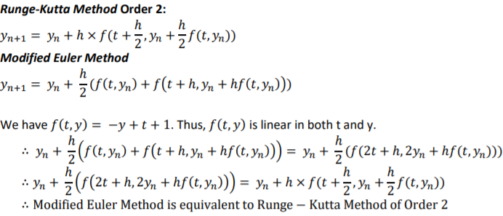

**Q3:**

1. Using the Modified Euler method, the solutions was approximated at certain points. It was then compared with the actual value at those points.

|  |  |  |  |
| --- | --- | --- | --- |
| h | x | Approximated value | Actual Value |
| 0.5 | 1.5 | 2.3541666666666665 | 2.3541019662496847 |
| 0.5 | 2.0 | 2.7417450827887775 | 2.7416573867739413 |

1. Using the Modified Euler method, the solutions was approximated at certain points. It was then compared with the actual value at those points.

|  |  |  |  |
| --- | --- | --- | --- |
| h | x | Approximated value | Actual Value |
| 0.25 | 1.25 | 1.4160750785402427 | 1.4031989692799332 |
| 0.25 | 1.5 | 1.0310110697781514 | 1.0164101466785118 |
| 0.25 | 1.75 | 0.7522666785837252 | 0.7380097715499843 |
| 0.25 | 2.0 | 0.5432450024334279 | 0.5296870980395587 |

**Q4:**

Euler’s method with h= 0.025, the Runge-Kutta second-order method with h=0.05, and the Runge-Kutta fourth-order method with h = 0.1 was employed and the approximate values were compared at the common mesh points of these methods 0.1,0.2,0.3,0.4, and 0.5.

|  |  |  |  |
| --- | --- | --- | --- |
| x | Euler | Runge-Kutta O-2 | Runge-Kutta O-4 |
| 0.1 | 0.655498 | 0.657373 | 0.657414 |
| 0.2 | 0.825338 | 0.829213 | 0.829298 |
| 0.3 | 1.008933 | 1.014939 | 1.015070 |
| 0.4 | 1.205635 | 1.213908 | 1.214087 |
| 0.5 | 1.414726 | 1.425409 | 1.425638 |

**Q5:**

Using the exact values of y(t) as the starting values and h as 0.2, the approximations (using explicit Adams-Bashforth 4 step method in part (a) and using implicit Adams-Bashforth 3 step method in part (b)). Difference in the values has also been calculated.

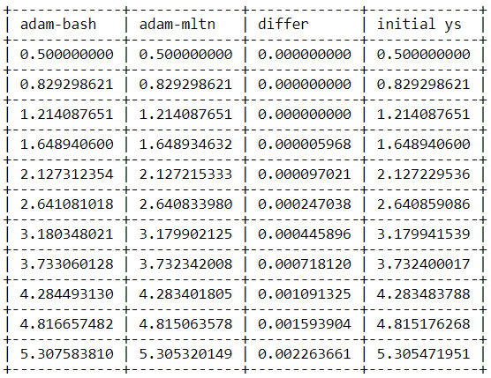

**Q6:**

Initial/Starting values were obtained from the 4th order Runge-Kutta method. These starting values were further used to approximate the solutions of given IVPs using Adam Bashforth method.

**(a)**

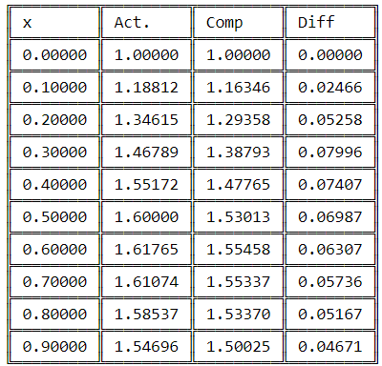

**(b)**



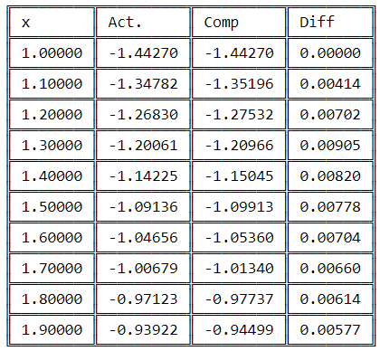

**(c)**



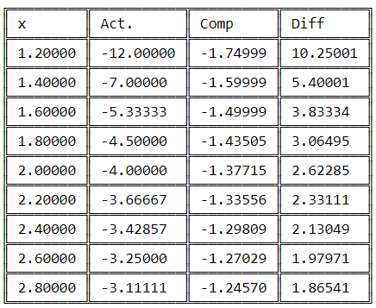

**Q7:**

Initial/Starting values were obtained from the 4th order Runge-Kutta method. These starting values were further used to approximate the solutions of given IVPs using Adam Bashforth 4th order predictor method.

